


Integrated Mathematics I Syllabus
William Adams, Instructor
(619)-605-8100 ext. 2205
E-mail: wadams@sandi.net
Room 205

Course Description: Integrated Mathematics combines topics and skills from different mathematical disciplines (including algebra, geometry, probability, and statistics) to enable students to use a variety of skills and strategies to become effective problem solvers and communicators of mathematics. Students will strive to achieve both Common Core content standards (what we know and are able to do) and practice standards (how we do it).
Topics included in Integrated Mathematics Course 1 include
- Graphing
- Expressions and equations
- Linear functions, including line-fitting
- Introduction to Geometry, congruence and transformations

A complete list of common core standards for this course may be found at http://www.cde.ca.gov/be/st/ss/documents/ccssmathstandardaug2013.pdf.
This course meets the first year math requirement for high school graduation, as well as the UC/CSU “C” requirement for college prep.

Text: Cuoco, et. al. Integrated CME Project Mathematics I. Educational Development Center, Inc., 2013.
We will use other instructional resources, as well.
Suggested Materials: Pencil, paper, graph paper, scientific or graphing calculator, laptop
All content and necessary links will be available on Canvas.
A limited number of graphing calculators will be available at the library. Checkout forms are available from Mr. Adams.

Grading:
Grading Categories Grading Scale

Unit Tests & Quizzes: 65% A 88%-100%
Midterm/Final Exam: 10% B 75% - 87%
Assignments & Group Work: 25% C 50% - 74%
D 35% - 49%
F below 35%
(*Note: grades will not be “rounded up.” Grades are cumulative, so no student should give up after a bad test, but instead use retake opportunities to demonstrate learning of the standards by the end of the semester.)
Level | Description of Mastery on Specific Standards
4 | Exceeding content-area standards
3 | Meeting content-area standards
2 | Approaching content-area standards
1 | Beginning progress towards content-area standards
0 | Insufficient evidence to determine level of performance

ASSESSMENTS:
Student assessments will provide multiple opportunities to demonstrate mastery of standards. Performance for each standard will be graded separately on a four-point rubric. Students can expect an assessment every one to two weeks on individual standards. All standards will be assessed at least twice over the course of the semester.

HOMEWORK AND CLASSWORK:
In-class activities, written responses and homework are in this category. Homework is generally assigned daily and is due the next day. Long term projects may also be assigned. Late work will be accepted up until one week before the end of each grading period. Incomplete work may be turned in for partial credit. Homework will be graded on a four-point rubric.
ABSENCES:
In the case of an absence, students have one day for each day missed to make up work. It is the student’s responsibility to come to me for any missed assignments. If a student is absent on the day of a test, he or she will make it up the day of return. At the end of the term, time may not allow for make up tests. Also, please schedule to be in class for end-of-term exams. If the student misses two or more days during the chapter due to illness, he or she may arrange a time with me to take the exam.
ASSISTANCE:
I will generally be available for tutoring every day before school and after school. Schoolwide tutoring is also available; students will be informed once the schedule becomes available.
PROGRESS REPORTS:
There are six six-week progress reports throughout the year. If a student receives a D or F on a 6- or 12- week progress report, the student is in danger of failing at the semester. Parents, please feel free to contact me to set up a conference so we can work together to help your student be successful in mathematics.
In addition to school progress reports, parents may view student progress in PowerSchool. Feel free to e-mail me at wadams@sandi.net with any questions about student progress or grades.
CLASSROOM EXPECTATIONS:
Be in class, be on time, be prepared.
Always do your best work.
Turn in work on time. (Your name is required for credit)
Participate in class discussions, work with your partner, team, or class, as appropriate.
Respect your teacher, your classmates, yourself.
Follow all school rules.

Appropriate Technology Use Policy

Guiding Principles
At CHHS, we acknowledge the power of technology in educational, personal, and career settings. Each student is issued an electronic device for educational purposes, and we expect it to be used for educational activities.

Student Chromebooks
- Students are responsible for bringing their charged Chromebooks daily
- Students are expected to use the device for classroom activities and homework
- Students understand that the school’s network provides a layer of security and blocks inappropriate websites, searches, and typed words, and may flag inappropriate content, language, and images
- Students are not to install programs that bypass or obscure school network security features
- Teachers may employ blocking or monitoring software to assist students’ focus on academic tasks

Personal Devices
- During instructional class periods, students are not permitted to use personal electronic devices, such as cell phones, wireless headphones, and smartwatches.

Supporting this policy, the following will occur:
- Announce - Daily: the teacher will announce and remind students to put their phones away.
- Warn - Daily: when needed.
- Hold—Ask students to put their phones in a safe place (my desk, a locked cabinet, a cute box, etc.) until the end of the period.
- Call Home - To discuss with parents and guardians if inappropriate use persists.
Referral for Student Support - If inappropriate use is persistent and distracting to the learning.

ACADEMIC HONESTY: Students are expected to complete their own work. Academic honesty and responsibility are expected of all Canyon Hills students. Copying someone else’s homework, turning in a paper done by someone else, plagiarism, copying from other printed resources without giving credit to the author, and/or giving or receiving answers, sharing answers, using “cheat sheets,” or other such devices, are all considered cheating. Consequences may include a “zero” on the assignment for a first offense, along with a U in citizenship. Please see Canyon Hills Honesty Policy on the website or in your student handbook for further information.

Canyon Hills High School Citizenship Grading Policy
Purpose: At Canyon Hills High School we are supporting each child’s development in becoming thoughtful and productive citizens who will inherit our global society. With that, we will be explicit and transparent in teaching and modeling for our students how to reach excellence in citizenship. Citizenship grades are the balance of a student’s general work habits, attitude, and behavior in class over the grading period, not the result of one day or one action. It is the culmination of a student’s willingness and efforts to help or hinder the student’s own progress, as well as that of the class and other students. Additionally, citizenship grades are not an evaluation of the child as a person.

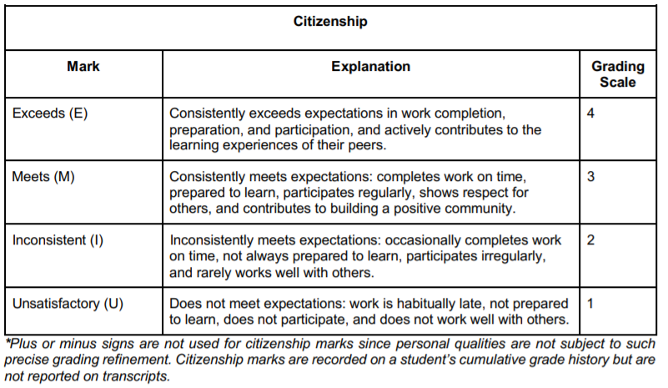
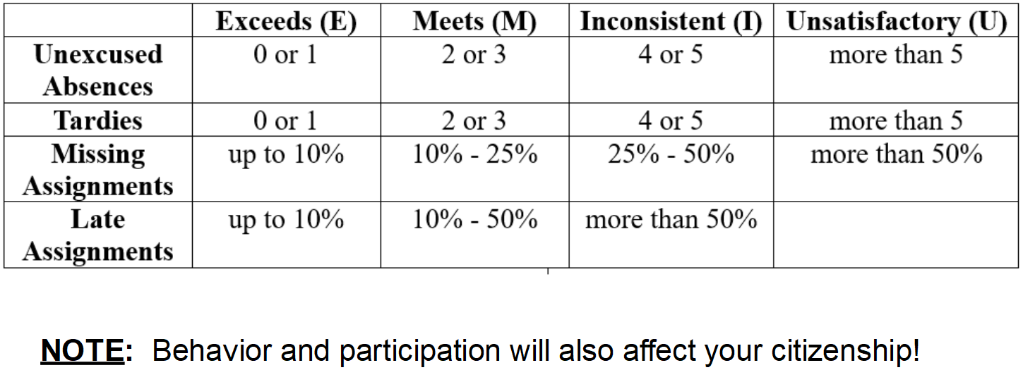

Thank you for taking the time to review this syllabus with your parent. If you or your parent have any questions, feel free to see me before or after class, or your parent may contact me at wadams@sandi.net‬‬

